

Initial Approach to Library Management System

Developed by…

Arko Kundu, D202105426

Dipayan Paul, D202105435

Purnendu Naskar, D202105440

Rishav Saha, D202105443

Swastik Sarkar,D202105468

Under the guidance & supervision of

# Arijit Dey

Department of Computer Science and Technology

The Calcutta Technical School

110, S. N. Banerjee Road, Kolkata – 700013

**Certificate**

This is to certify that Arko Kundu, Dipayan Paul, Purnendu Naskar, Rishav Saha & Swastik Sarkar , student of Diploma in Computer Science & Technology department of The Calcutta Technical School has done their Minor Project entitled ‘Initial approach to Library Management System’ under my supervision for their diploma course work.

Arijit Dey

Department of Computer Science and Technology

The Calcutta Technical School

**Certificate**

This is to certify that Arko Kundu, student of Diploma in Computer Science & Technology department of The Calcutta Technical School has done his Minor Project entitled ‘Initial approach to Library Management System’ under my supervision for their diploma course work.

Arijit Dey

Department of Computer Science and Technology

The Calcutta Technical School

**Certificate**

This is to certify that Dipayan Paul , student of Diploma in Computer Science & Technology department of The Calcutta Technical School has done his Minor Project entitled ‘Initial approach to Library Management System’ under my supervision for their diploma course work.

Arijit Dey

Department of Computer Science and Technology

The Calcutta Technical School

**Certificate**

This is to certify that Purnendu Naskar, student of Diploma in Computer Science & Technology department of The Calcutta Technical School has done their Minor Project entitled ‘Initial approach to Library Management System’ under my supervision for his diploma course work.

Arijit Dey

Department of Computer Science and Technology

The Calcutta Technical School

**Certificate**

This is to certify that Rishav Saha, student of Diploma in Computer Science & Technology department of The Calcutta Technical School has done their Minor Project entitled ‘Initial approach to Library Management System’ under my supervision for his diploma course work.

Arijit Dey

Department of Computer Science and Technology

The Calcutta Technical School

**Certificate**

This is to certify that Swastik Sarkar , student of Diploma in Computer Science & Technology department of The Calcutta Technical School has done their Minor Project entitled ‘Initial approach to Library Management System’ under my supervision for his diploma course work.

Arijit Dey

Department of Computer Science and Technology

The Calcutta Technical School

## Acknowledgement

Place : Kolkata

Date : 00.00.2022

We would like to express my profound gratitude to Mr. Arijit Dey, HOD of Computer Science & Technology department of The Calcutta Technical School for his contributions to the completion of our project titled ‘Initial Approach to Library Management System.

We would like to express our special thanks to our mentor Mr. Arijit Dey for his time and efforts he provided throughout the Semester. Your useful advice and suggestions were really helpful to us during the project’s completion. In this aspect, we are eternally grateful to you.

We would like to acknowledge that this project was completed entirely by us and not by someone else.

**Arko Kundu, D202105426**

**Dipayan Paul, D202105435**

**Purnendu Naskar, D202105440**

**Rishav Saha, D202105443**

**Swastik Sarkar, D202105468**

## Table of Contents

|  |  |  |
| --- | --- | --- |
| **Sl. No.** | **Particulars** | **Page No.** |
| 1 | Introduction | 01 |
| 2 | Motivation | 02 |
| 3 | Overview of the Project | 03 |
| 4 | Detail Description of the Project | 04 - 08 |
| 5 | Deep Dive into the Project | 09 - 38 |
| 6 | Conclusion and Scope of Further Study | 39 |
| 7 | References | 40 |

1. **Introduction**

A college library management website is a project that manages and stores books information electronically according to students needs. The system helps both students and library manager to keep a constant track of all the books available in the library. It allows both the admin and the student to search for the desired book. It becomes necessary for colleges to keep a continuous check on the books issued and returned and even calculate fine. This task if carried out manually will be tedious and includes chances of mistakes. These errors are avoided by allowing the system to keep track of information such as issue date, last date to return the book and even fine information and thus there is no need to keep manual track of this information which thereby avoids chances of mistakes.

Thus this system reduces manual work to a great extent allows smooth flow of library activities by removing chances of errors in the details.

A library is a pool of sources of information. This similar resources had made a well-defined community including readers, students etc to refer or to borrow the book more conveniently. The Library Management System Software for Library Management is used to find books and access journals easily. The library automation system automates the typical procedures of libraries and reduces the workload for library staffs. It makes the consistency of the record and the standard quality. When people value information more and more, the information industry got developed and the technology changed the expectations of library patrons. It gives both an opportunity and challenge to the libraries. The integrated library system is used to manage the more-complex activities and it enables the librarian to manage library resources in a more effective way to save time and effort.

1. **Motivation**

To store all the information in the database from where user will place their query and get the results on the basis of their query. Only valid users will be able to access this website. Through this Library Management System, it will be easy to manage accounts and various details of particular student and employees working under library along with the records of book.

The current Library Management System does not eliminate the process of searching books within the library campus. Students have to find books manually. They have to wait until they are not provided with their library card and token. For receiving book they have to show their library card and wait in line for their turns. The admin personnel also have to look manually on which day which person will take the charge within library to manage the overall work.

The current Library Management System does not eliminate the process of searching books within the library campus. Students have to find books manually. They have to wait until they are not provided with their library card and token. For receiving book they have to show their library card and wait in line for their turns. The admin personnel also have to look manually on which day which person will take the charge within library to manage the overall work.

1. **Overview of the Project**

This Library Management System will have login page from where its user can access. This page will provide login for the students only. To access the library resources students have to register by using their name, registration number, roll number, library id, and their department. After successful registration they will be provided the login facility and access to Library.

Students can search books by using book by title of book along with author name or simply the title of the book or any other fields as per their choice. After completion of this process students will be provided with book details and the student can add the book to the demand list. After the book is demanded, his demand list on the dashboard will be updated and an accession number of the book would be shown. After successfully borrowing the book from the library, the borrowed list will be updated.

If any student has lost their book, then this should be informed to library working staff member where they can made changes to their account and take appropriate actions such as fine.

Admin will able to add students, delete students, add books, manage account details etc.

1. **Detail Description of the Project**

**Modules:**

1. **About Page**

This is the first page of our website. Here you will get the first interface of our website. In the top vertical navigation bar, starting from left, you will find our logo first, then “CTS Library” is written. After that, the most right side of that page will show you a Login option which on selecting will open the Student Login page. Going below the navigation bar will show you a small description about our college and after that a slideshow of some interior parts of library has been shown. At last a small footer is used as a copyright symbol. You will see About, Go to Dashboard and Contact us sections respectively in the navigation bar of about page after the user has signed in.

1. **Student login and logout**

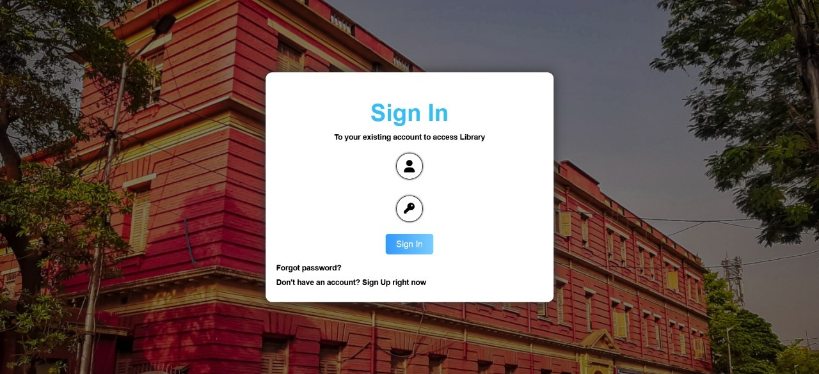

In this particular page, students can login into their personal account using their username, i.e their Library Card ID and password as entered in the database. Currently the forgot password and the password changing feature is not available here which will be included in future. After signing in successfully through their correct password, they will re-directed to Student Dashboard. You can also logout from small dropdown section of the profile button in the dashboard.

1. **Dashboard**

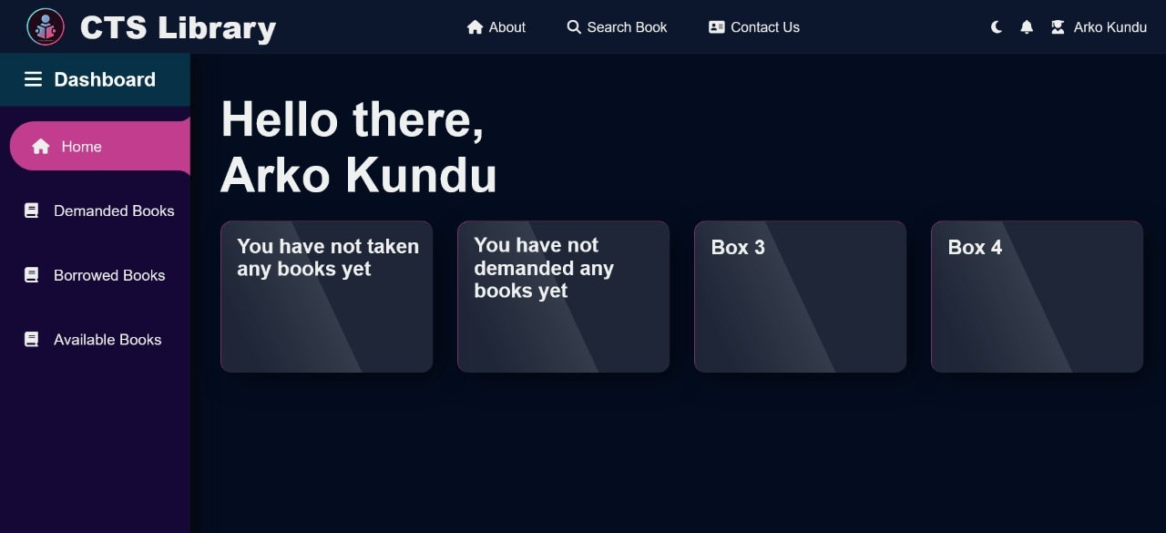

This page is a major page which will allow users to Search book, Demand book, and lot of main functions through this page. First of all, the top vertical navigation bar is more as same as that of the About page .At the rightmost corner of the navigation bar, a profile account is created as the name of the user, which on clicking dropdown three more option including a profile button. Clicking the profile button will appear the details of the User such as Name, Roll Number, Department , Year, etc. and also their groupmates will be shown below through a slideshow.

Coming next to the side bar, it shows Home, Demanded Books and Borrowed Book, which will allow you to navigate that within the single page. Again coming to the section after top navigation bar, where comes the Home part. It shows “Hello There,” and the name of the respective student’s name who have logged in. Next comes the gridbox section where demanded books, borrowed books along with the book’s title and author’s name will be shown shortly.

After that in the Demanded book section, a html table is created where the column heading is given as Acc. No, Title, Author, Publisher and Edition. This table will be filled only if the student has demanded any book, otherwise it will be showing “You have not demanded any books yet”. If the student has demanded any book, the student can only give the next demand after 3 days and if a student has demanded 3 books, then he/she cannot demand any books further.

Then comes, Borrowed books section, where it shows borrowed books html table similar to demanded books section.

The return book option and cancel demand option will be added in further improvement.

1. **Search option**

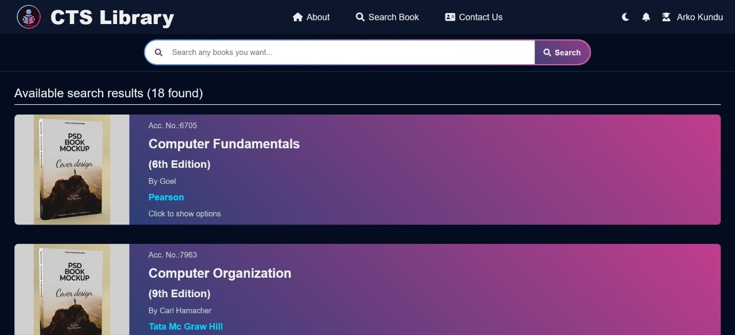

On clicking the search option of the top navigation bar, you will be redirected to another page. In this search menu, you can first see a search bar where you can search the specific books you want to demand. You should either search by book title or author’s name. If you search a book which is there in the database, then you can add that book into the demand list. If the search option cannot find that book inside the database, it will show that “No such book is there”.

1. **Place & View Demand**

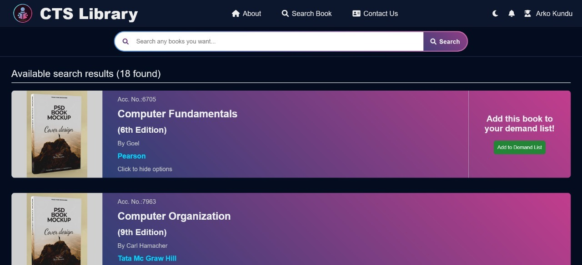

After giving a successful demand from the search menu, you can see on the demanded books section of the dashboard, where you will see which book you have demanded along with their details. Students can give only one book demand at a time and can further give another demand after 3 days. The student is also limited to demand only 3 books at each semester.

1. **Student’s Profile**

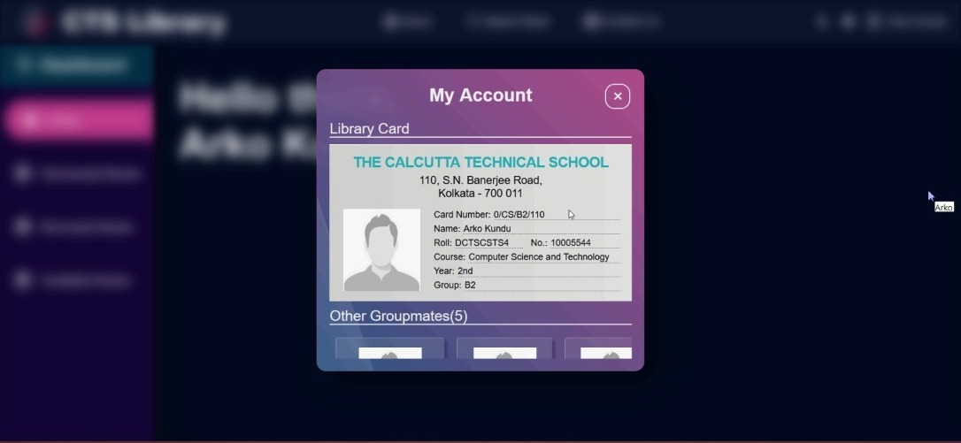

Students can see their profile by clicking on the dropdown section of profile option in top navigation bar. Here, they will observe their full profile details such as Name, Roll Number Department, Year, Group and along with the profile of their groupmates.

**Advantages:**

* The system excludes the use of paper work by managing all the book information electronically.
* Students can demand book from anywhere either in library or in home or anywhere else.
* The system has books well organized and systematically arranged in different categories in the system so that user can easily search and find the book. Searching books is through title and author’s name.
* Privacy and protection is given through the password of students during the login option. None else can give anyone else’s demand from their account, not even their group members’.
* Thus, it saves human efforts and resources.

**Disadvantages:**

* The system is not automatic and the student has to inform the librarian after demanding the book.
* The system is currently on localhost service from phpMyAdmin, so not everyone else can use this system. (Further modification will be required).
* The Admin procedure system is not valid. Further modification will be done for Admin facilities.

**Features:**

* Easily manage the complete management of your library through the software's easy interface.
* Removes manual process of issuing books and simplifies the way of issuing book to save time and effort.
* The system helps you to find the fine levied by automatically counting days from the date of issue in case of late return of the book.
* Easy to generate a customized report for library items, library inventory, and library fine collection.

|  |  |  |
| --- | --- | --- |
| **SI No.** | **Title** | **Page No.** |
| 1. | Types of Programming Languages used | 10 - 13 |
| 2. | Use of Database | 14 – 16 |
| 3. | Use of Php | 16 – 20 |
| 4. | Sessions in Php | 20 – 22 |
| 5. | Queries in SQL | 22 - 23 |
| 6. | Use of Java Script | 24 – 29 |
| 7. | Use of PhpMyAdmin | 29 - 32 |
| 8. | Use of CSS | 32 – 33 |
| 9. | Programming through VSCode | 33 - 34 |
| 10. | Total Procedure of Searching, demanding and borrowing a book | 34 - 36 |
| 11. | Rules and Regulations | 36 - 37 |
| 12. | DFD Model | 38 |

1. **Deep Dive into the Project**

**Types of Programming Language used :**



The HyperText Markup Language or HTML is the standard markup language for documents designed to be displayed in a web browser. It can be assisted by technologies such as Cascading Style Sheets (CSS) and scripting languages such as JavaScript.

Web browsers receive HTML documents from a web server or from local storage and render the documents into multimedia web pages. HTML describes the structure of a web page semantically and originally included cues for the appearance of the document.

HTML elements are the building blocks of HTML pages. With HTML constructs, images and other objects such as interactive forms may be embedded into the rendered page. HTML provides a means to create structured documents by denoting structural semantics for text such as headings, paragraphs, lists, links,

quotes and other items. HTML elements are delineated by tags, written using angle brackets. Tags such as <img /> and <input /> directly introduce content into the page. Other tags such as <p> surround and provide information about document text and may include other tags as sub-elements. Browsers do not display the HTML tags but use them to interpret the content of the page.

HTML can embed programs written in a scripting language such as JavaScript, which affects the behaviour and content of web pages. Inclusion of CSS defines the look and layout of content. The World Wide Web Consortium (W3C), former maintainer of the HTML and current maintainer of the CSS standards, has encouraged the use of CSS over explicit presentational HTML since 1997.A form of HTML, known as HTML5, is used to display video and audio, primarily using the <canvas> element, in collaboration with javascript.

Cascading Style Sheets (CSS) is a style sheet language used for describing the presentation of a document written in a markup language such as HTML or XML (including XML dialects such as SVG, MathML or XHTML).CSS is a cornerstone technology of the World Wide Web, alongside HTML and JavaScript.

CSS or Cascading Style Sheets is designed to enable the separation of presentation and content, including layout, colors, and fonts. This separation can improve content accessibility; provide more flexibility and control in the specification of presentation characteristics; enable multiple web pages to share formatting by specifying the relevant CSS in a separate .css file, which reduces complexity and repetition in the structural content; and enable the .css file

to be cached to improve the page load speed between the pages that share the file and its formatting.

Separation of formatting and content also makes it feasible to present the same markup page in different styles for different rendering methods, such as on-screen, in print, by voice (via speech-based browser or screen reader), and on Braille-based tactile devices. CSS also has rules for alternate formatting if the content is accessed on a mobile device.

The name cascading comes from the specified priority scheme to determine which style rule applies if more than one rule matches a particular element. This cascading priority scheme is predictable.

The CSS specifications are maintained by the World Wide Web Consortium (W3C). Internet media type (MIME type) text/css is registered for use with CSS by RFC 2318 (March 1998). The W3C operates a free CSS validation service for CSS documents.

In addition to HTML, other markup languages support the use of CSS including XHTML, plain XML, SVG, and XUL.



PHP is a general-purpose scripting language geared toward web development. It was originally created by Danish-Canadian programmer Rasmus Lerdorf in 1994. The PHP reference implementation is now produced by The PHP Group. PHP originally stood for Personal Home Page, but it now stands for the recursive initialism PHP: Hypertext Pre-processor.

PHP code is usually processed on a web server by a PHP interpreter implemented as a module, a daemon or as a Common Gateway Interface (CGI) executable. On a web server, the result of the interpreted and executed PHP code – which may be any type of data, such as generated HTML or binary image data – would form the whole or part of an HTTP response. Various web template systems, web content management systems, and web frameworks exist which can be employed to orchestrate or facilitate the generation of that response. Additionally, PHP can be used for many programming tasks outside the web context, such as standalone graphical applications and

robotic drone control. PHP code can also be directly executed from the command line.

The standard PHP interpreter, powered by the Zend Engine, is free software released under the PHP License. PHP has been widely ported and can be deployed on most web servers on a variety of operating systems and platforms.

The PHP language evolved without a written formal specification or standard until 2014, with the original implementation acting as the de facto standard which other implementations aimed to follow. Since 2014, work has gone on to create a formal PHP specification.

W3Techs reports that, as of January 2022, "PHP is used by 78.1% of all the websites whose server-side programming language we know." PHP version 7.4 is the most used version. Support for version 7.3 was dropped on 6 December 2021.

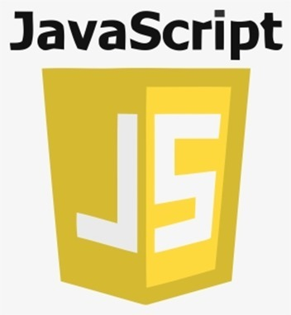

JavaScript often abbreviated JS, is a programming language that is one of the core technologies of the World Wide Web, alongside HTML and CSS.As of 2022, 98% of websites use JavaScript on the client side for webpage behaviour, often incorporating third-party libraries. All major web browsers have a dedicated JavaScript engine to execute the code on users' devices.

JavaScript is a high-level, often just-in-time compiled language that conforms to the ECMAScript standard. It has dynamic typing, prototype-based object-orientation, and first-class functions. It is multi-paradigm, supporting event-driven, functional, and imperative programming styles. It has application programming interfaces (APIs) for working with text, dates, regular expressions, standard data structures, and

the Document Object Model (DOM).

The ECMAScript standard does not include any input/output (I/O), such as networking, storage, or graphics facilities. In practice, the web browser or other runtime system provides JavaScript APIs for I/O.

JavaScript engines were originally used only in web browsers, but are now core components of some servers and a variety of applications. The most popular runtime system for this usage is Node.js.

Although Java and JavaScript are similar in name, syntax, and respective standard libraries, the two languages are distinct and differ greatly in design.



SQL (Structured Query Language) is a domain-specific language used in programming and designed for managing data held in a relational database management system (RDBMS), or for stream processing in a relational data stream management system (RDSMS). It is particularly useful in handling structured data, i.e. data incorporating relations among entities and variables.

SQL offers two main advantages over older read–write APIs such as ISAM or VSAM. Firstly, it introduced the concept of accessing many records with one single command. Secondly, it eliminates the need to specify how to reach a record, e.g. with or without an index.

Originally based upon relational algebra and tuple relational calculus, SQL consists of many types of statements,[6] which may be informally classed as sublanguages, commonly: a data query language (DQL),[a] a data definition language (DDL),[b] a data control language (DCL), and a data manipulation language (DML).[c][7] The scope of SQL includes data query, data manipulation (insert, update, and delete), data definition (schema creation and modification), and data access control. Although SQL is essentially a declarative language (4GL), it also includes procedural elements.

SQL was one of the first commercial languages to use Edgar F. Codd’s relational model. The model was described in his influential 1970 paper, "A Relational Model of Data for Large Shared Data Banks".[8] Despite not entirely adhering to the relational model as described by Codd, it became the most widely used database language.[9][10]

**Use of Database :**

What is Database?

A database is information that is set up for easy access, management and updating. Computer databases typically store aggregations of data records or files that contain information, such as sales transactions, customer data, financials and product information.

Databases are used for storing, maintaining and accessing any sort of data. They collect information on people, places or things. That information is gathered in one place so that it can be observed and analyzed . Databases can be thought of as an organized collection of information.

What are databases used for?

Businesses use data stored in databases to make informed business decisions. Some of the ways organizations use databases include the following:

Improve business processes. Companies collect data about business processes, such sales, order processing and customer service. They analyze that data to improve these processes, expand their business and grow revenue.

Keep track of customers. Databases often store information about people, such as customers or users. For example, social media platforms use databases to store user information, such as names, email addresses and user behaviour. The data is used to recommend contentto users and improve the user experience.

Secure personal health information. Healthcare providers use databases to securely store personal health data to inform and improve patient care.

Store personal data. Databases can also be used to store personal information. For example, personal cloud storage is available for individual users to store media, such as photos, in a managed cloud.



MySQL is an open-source relational database management system (RDBMS). Its name is a combination of "My", the name of co-founder Michael Widenius's daughter My, and "SQL", the abbreviation for Structured Query Language. A relational database organizes data into one or more data tables in which

data may be related to each other; these relations help structure the data. SQL is a language programmers use to create, modify and extract data from the relational database, as well as control user access to the database. In addition to relational databases and SQL, an RDBMS like MySQL works with an operating system to implement a relational database in a computer's storage system, manages users, allows for network access and facilitates testing database integrity and creation of backups.

MySQL is free and open-source software under the terms of the GNU General Public License, and is also available under a variety of proprietary licenses. MySQL was owned and sponsored by the Swedish company MySQL AB, which was bought by Sun Microsystems (now Oracle Corporation). In 2010, when Oracle acquired Sun, Widenius forked the open-source MySQL project to create MariaDB.

MySQL has stand-alone clients that allow users to interact directly with a MySQL database using SQL, but more often, MySQL is used with other programs to implement applications that need relational database capability. MySQL is a component of the LAMP web application software stack (and others), which is an acronym for Linux, Apache, MySQL, Perl/PHP/Python. MySQL is used by many database-driven web applications, including Drupal, Joomla, phpBB, and WordPress. MySQL is also used by many popular websites, including Facebook, Flickr, MediaWiki, Twitter, and YouTube.

Advantages of MySQL :

* Fast and high Performance database.
* Easy to use, maintain and administer.
* Easily available and maintain integrity of database.
* Provides scalability, usability and reliability.
* Low cost hardware.
* MySQL can read simple and complex queries and write operations.



XAMPP is a free and open-source cross-platform web server solution stack package developed by Apache Friends, consisting mainly of the Apache HTTP Server, MariaDB database, and interpreters for scripts written in the PHP and Perl programming languages. Since most actual web server deployments use the same components as XAMPP, it makes transitioning from a local test server to a live server possible.

XAMPP's ease of deployment means a WAMP or LAMP stack can be installed quickly and simply on an operating system by a developer, with the advantage that common add-in applications such as WordPress and Joomla! can also be installed with similar ease using Bitnami.

In this particular page, all users have to Sign in through their username and password. The users who are Admin will “Sign in as Admin” and the users for are students will “Sign in as Students”.

If anyone does not have a account created, the user must signup either as Admin or as Student. The framework of the Sign in page is created using Html and CSS. The backend of this page is created using Php.

A database is created for the users who will be signing as Admin and Student by using MySql.

**Use of PHP :**

PHP is an acronym for "PHP: Hypertext Pre-processor".

What Can PHP Do?

* PHP can generate dynamic page content
* PHP can create, open, read, write, delete, and close files on the server
* PHP can collect form data
* PHP can send and receive cookies
* PHP can add, delete, modify data in your database
* PHP can be used to control user-access
* PHP can encrypt data

Advantages of PHP :

* PHP has some advantages that have made it so popular, and it's been the go-to language for web servers for more than 15 years now. Here are some of PHP's benefits:
* Cross-Platform: PHP is platform-independent. You don't have to have a particular OS to use it because it runs on every platform, whether it's Mac, Windows, or Linux.
* Open Source: PHP is open source. The original code is made available to everyone who wants to build upon it. This is one of the reasons why one of its frameworks, Laravel, is so popular.
* Easy to learn: PHP is not hard to learn for absolute beginners. You can pick it up pretty if you already have programming knowledge.
* PHP syncs with all Databases: You can easily connect PHP to all Databases, relational and non-relational. So it can connect in no time to MySQL, Postgress, MongoDB, or any other database.
* Supportive Community: PHP has a very supportive online community. The official documentation provides guides on how to use the features and you can easily get your problem fixed while stuck.

Who uses PHP?

A number of established companies and tech giants use PHP to run their servers and make a lot of incredible things.

Facebook: Facebook uses PHP to power its site. In turn, the company contributed to the community by creating an implementation known as Hip Hop for PHP.

Wikipedia: one of the world's largest sources of information on any topic, Wikipedia is built in PHP.

Content Management Systems (CMSs): the world's most popular content management system, WordPress, is built in PHP. Other content management systems such as Drupal, Joomla, and Magento are also built in PHP. Shopify runs on PHP too.

Web Hosting Platforms: a lot of Web Hosting Platforms such as BlueHost, Site ground, and Whogohost run their hosting servers using PHP.

How can you run php files?

-Php can only through XAMPP ,WAMP or any other means which will run Personal Home Page scripts on your computer locally. For XAMPP, you have to insert particular folder in which you are writing the php into the htdocs file . On the browser, type localhost/filename.php and you can see the inside text of that file.

Basic Syntax of Php :

PHP scripts can be placed anywhere in a document, and always start with <?php and end with ?>. Also, PHP statements end with a semicolon (;).

Here's a simple script that uses the built-in echo function to output the text "The Best PHP Examples" to the page :

<!DOCTYPE html>

<html>

<body>

<h1>Developer News</h1>

<?php echo "The Best PHP Examples"; ?>

</body>

</html>

The output of that would be:

Developer News

The Best PHP Examples

Comments

PHP supports several ways of commenting:

Single-line comments:

Multi-line comments:

<?php

// This is a single-line comment

# You can also make single-line comments like this

?>

<?php

/*

This comment block spans

over multiple

lines

*/

?>

Case Sensitivity

All keywords, classes, and functions are NOT case sensitive.

In the example below, all three echo statements are valid:

<?php

ECHO "Hello!<br>";

echo "Welcome to Developer News<br>";

EcHo "Enjoy all of the ad-free articles<br>";

?>

However, all variable names are case sensitive. In the example below, only the first statement is valid and will display the value of the $name variable. $NAME and $NaMe are both treated as different variables:

<?php

$name = "Quincy";

echo "Hi! My name is " . $name . "<br>";

echo "Hi! My name is " . $NAME . "<br>";

echo "Hi! My name is " . $NaMe . "<br>";

?>

Variables

Variables are the main way to store information in a PHP program.

All variables in PHP start with a leading dollar sign like $variable_name. To assign a variable, use the = operator, with the name of the variable on the left and the expression to be evaluated on the right.

Syntax :

<?php

// Assign the value "Hello!" to the variable "greeting"

$greeting = "Hello!";

// Assign the value 8 to the variable "month"

$month = 8;

// Assign the value 2019 to the variable "year"

$year = 2019;

?>

Rules for PHP variables

Variable declarations starts with $, followed by the name of the variable

Variable names can only start with an upper or lowercase letter or an underscore (_)

Variable names can only contain letters, numbers, or underscores (A-z, 0-9, and _). Other special characters like + - % ( ) . & are invalid

Variable names are case sensitive

Some examples of allowed variable names :

$my_variable

$anotherVariable

$the2ndVariable

Predefined Variables

PHP has several special keywords that, while they are "valid" variable names, cannot be used for your variables. The reason for this is that the language itself has already defined those variables and they have are used for special purposes. Several examples are listed below, for a complete list see the PHP documentation site.

$this

$_GET

$_POST

$_SERVER

$_FILES

PHP Data Types

Variables can store data of different types such as:

String ("Hello")

Integer (5)

Float (also called double) (1.0)

Boolean ( 1 or 0 )

Array ( array("I", "am", "an", "array") )

Object

NULL

Resource

Strings

A string is a sequence of characters. It can be any text inside quotes (single or double):

$x = "Hello!";

$y = 'Hello!';

Integers

An integer data type is a non-decimal number between -2,147,483,648 and 2,147,483,647.

Rules for integers:

Integers must have at least one digit

Integers must not have a decimal point

Integers can be either positive or negative

$x = 5;

Floats

A float, or floating point number, is a number with a decimal point.

$x = 5.01;

Booleans

A Boolean represents two possible states: TRUE or FALSE. Booleans are often used in conditional testing.

$x = true;

$y = false;

Arrays

An array stores multiple values in one single variable.

$colors = array("Magenta", "Yellow", "Cyan");

NULL

Null is a special data type that can only have the value null. Variables can be declared with no value or emptied by setting the value to null. Also, if a variable is created without being assigned a value, it is automatically assigned null.

<?php

// Assign the value "Hello!" to greeting

$greeting = "Hello!";

// Empty the value greeting by setting it to null

$greeting = null;

?>

**Sessions in PHP :**

A session is a way to store information (in variables) to be used across multiple pages.

Unlike a cookie, the information is not stored on the users computer.

What is a PHP Session?

-When you work with an application, you open it, do some changes, and then you close it. This is much like a Session. The computer knows who you are. It knows when you start the application and when you end. But on the internet there is one problem: the web server does not know who you are or what you do, because the HTTP address doesn't maintain state.

Session variables solve this problem by storing user information to be used across multiple pages (e.g. username, favorite color, etc). By default, session variables last until the user closes the browser.

So; Session variables hold information about one single user, and are available to all pages in one application.

Start a PHP Session:

A session is started with the session_start() function.

Session variables are set with the PHP global variable: $_SESSION.

Example:

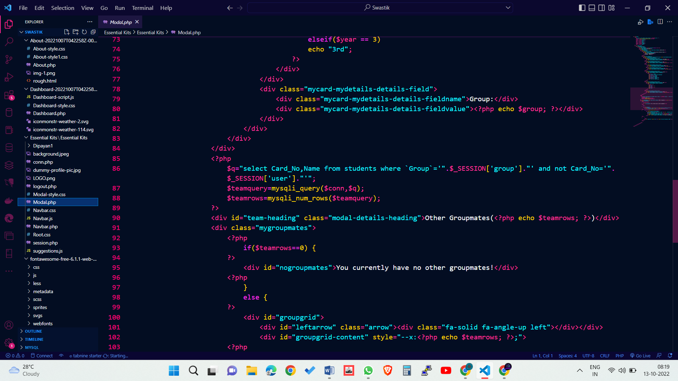

PHP destroying sessions:

PHP session_destroy() function is used to destroy all session variables completely.

<?php

session_start();

session_destroy();

?>

How are sessions better than cookies?

-Although cookies are also used for storing user related data, they have serious security issues because cookies are stored on the user’s computer and thus they are open to attackers to easily modify the content of the cookie. Addition of harmful data by the attackers in the cookie may result in the breakdown of the application.

Apart from that cookies affect the performance of a site since cookies send the user data each time the user views a page. Every time the browser requests a URL to the server, all the cookie data for that website is automatically sent to the server within the request.

Important Points:

* The session IDs are randomly generated by the PHP engine .
* The session data is stored on the server therefore it doesn’t have to be sent with every browser request.
* The session_start() function needs to be called at the beginning of the page, before any output is generated by the script in the browser.

PHP mysql query() Function

Definition and Usage

The query() / mysqli_query() function performs a query against a database.

Syntax

Object oriented style:

$mysqli -> query(query, resultmode)

Procedural style:

mysqli_query(connection, query, resultmode)

Parameter Values

|  |  |
| --- | --- |
| **Parameter** | **Description** |
| *connection* | Required. Specifies the MySQL connection to use |
| *query* | Required. Specifies the SQL query string |
| *resultmode* | Optional. A constant. Can be one of the following:   * MYSQLI_USE_RESULT (Use this to retrieve large amount of data) * MYSQLI_STORE_RESULT (This is default) |

Example :

<?php

$mysqli = new mysqli("localhost","my_user","my_password","my_db");

// Check connection

if ($mysqli -> connect_errno) {

echo "Failed to connect to MySQL: " . $mysqli -> connect_error;

exit();

}

// Perform query

if ($result = $mysqli -> query("SELECT * FROM Persons")) {

echo "Returned rows are: " . $result -> num_rows;

// Free result set

$result -> free_result();

}

$mysqli -> close();

?>

**Queries in SQL :**

The basis of a query in SQL Server is the SELECT sentence which allows to select the data to be displayed. To start with this, we will use the librarysystem database that contains sample tables and views which will allow us to have the same tables and data. We will also be able to work with multiple tables already created.

Examples are:

1) MySQL Create Database

MySQL create database is used to create database. For example

create database db1;

2) MySQL Select/Use Database

MySQL use database is used to select database. For example

use db1;

3) MySQL Create Query

MySQL create query is used to create a table, view, procedure and function. For example:

CREATE TABLE customers

(id int(10),

name varchar(50),

city varchar(50),

PRIMARY KEY (id )

);

4) MySQL Alter Query

MySQL alter query is used to add, modify, delete or drop colums of a table. Let's see a query to add column in customers table:

ALTER TABLE customers

ADD age varchar(50);

5) MySQL Insert Query

MySQL insert query is used to insert records into table. For example:

insert into customers values(101,'rahul','delhi');

6) MySQL Update Query

MySQL update query is used to update records of a table. For example:

update customers set name='bob', city='london' where id=101;

7) MySQL Delete Query

MySQL update query is used to delete records of a table from database. For example:

delete from customers where id=101;

8) MySQL Select Query

Oracle select query is used to fetch records from database. For example:

SELECT * from customers;

9) MySQL Truncate Table Query

MySQL update query is used to truncate or remove records of a table. It doesn't remove structure. For example:

truncate table customers;

10) MySQL Drop Query

MySQL drop query is used to drop a table, view or database. It removes structure and data of a table if you drop table. For example:

drop table customers;

**Use of JavaScript :**

Javascript is used by programmers across the world to create dynamic and interactive web content like applications and browsers. JavaScript is so popular that it's the most used programming language in the world, used as a client-side programming language by 97.0% of all websites. Client-side languages are those whose action takes place on the user's computer, rather than on the server.

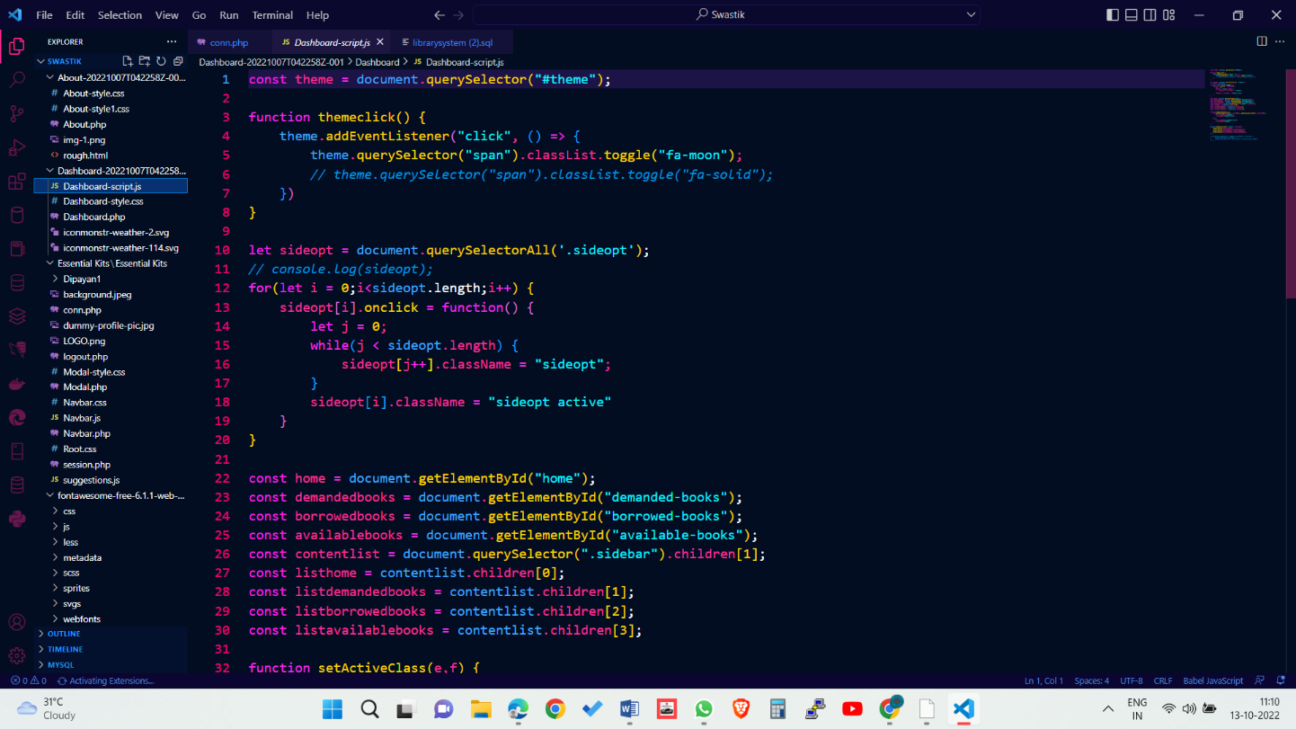

JavaScript is versatile enough to be used for a variety of different applications, like software, hardware controls, and servers. JavaScript is most known for being a web-based language, because it's native to the web browser. The web browser can naturally understand the language, like how a native English speaker can naturally understand English.

JavaScript has evolved over the past 25 years to become a versatile and accessible programming language for working with web browsers. Developers use JavaScript to build complex interactive websites and browser games, and to connect servers to websites and web applications. Because of this versatility, it’s easy to see why this language is the most commonly used programming language in the world.

JavaScript was designed for :

* Speed : it’s faster to execute code within a web browser in its native language than it is to execute code on the server.
* Dynamic pages : pages that users can interact with weren’t possible before JavaScript’s inception.
* Reducing memory use : executing the code in the browser helps free up space on servers, which helps cut costs.
* Building responsive user interfaces : almost all social media user interfaces rely on JavaScript.
* Reloading certain parts of the page independently: those suggestions when you start typing in Google’s search bar are all thanks to JavaScript.
* Responsive content : when you change your browser window’s size, JavaSCript lets the size of the content on the page change with it.
* Form validation : required fields are enforced by JavaScript, so that you don’t miss any information when you’re shopping online.
* Autocomplete : JavaScript helps save us from manually inputting our email address every time we fill out an online form.
* Playing audio and video : remember Flash? JavaScript’s audio and video capabilities are the reason it’s now obsolete. Later, HTML was updated to handle media files too, but JavaScript did it first.

Why do we Need JavaScript?

-Whether you plan to specialize in front-end, back-end, or full-stack development, JavaScript is a crucial programming language for any web developer. Without JavaScript, we wouldn’t have the dynamic and interactive web pages that have become the standard user experience we all know, love, and rely on.

How to implement JS?

-JavaScript can be implemented using JavaScript statements that are placed within the <script>... </script> HTML tags in a web page.

You can place the <script> tags, containing your JavaScript, anywhere within your web page, but it is normally recommended that you should keep it within the <head> tags.

The <script> tag alerts the browser program to start interpreting all the text between these tags as a script. A simple syntax of your JavaScript will appear as follows.

<script ...>

JavaScript code

</script>

The script tag takes two important attributes −

Language − This attribute specifies what scripting language you are using. Typically, its value will be javascript. Although recent versions of HTML (and XHTML, its successor) have phased out the use of this attribute.

Type − This attribute is what is now recommended to indicate the scripting language in use and its value should be set to "text/javascript".

So your JavaScript segment will look like −

<script language = "javascript" type = "text/javascript">

JavaScript code

</script>

Basic Syntax of Java Script :

JavaScript Variables: A JavaScript variable is the simple name of storage location where data to be stored. There are two types of variables in JavaScript which are listed below:

1. Local variables: Declare a variable inside of block or function.
2. Global variables: Declare a variable outside function or with a window object.

Example:

<script>

// Declare a variable and initialize it

// Gloabal variable declaration

var Name="Apple";

// Function definition

function MyFunction() {

// Local variable declaration

var num = 45;

// Display the value of Gloabal variable

document.writeln(Name);

// Display the value of local variable

document.writeln("<br>" + num );

}

// Function call

MyFunction();

</script>

Output:

Apple

45

JavaScript Operator : JavaScript operators are symbols that are used to compute the value or in other word we can perform operations on operands. Arithmetic operators ( +, -, *, / ) are used to compute the value and Assignment operator ( =, +=, %= ) are used to assign the values to variables.

Example:

<script>

// Variable Declarations

var x, y, sum;

// Assign value to the variables

x = 3;

y = 23;

// Use arithmetic operator to

// add two numbers

sum = x + y;

document.write(sum);

</script>

Output:

26

JavaScript Expression: Expression is the combination of values, operators, and variables. It is used to compute the values.

Example:

<script>

// Variable Declarations

var x, num, sum;

// Assign value to the variables

x = 20;

y = 30

// Expression to divide a number

num = x / 2;

// Expression to add two numbers

sum = x + y;

document.write(num + "<br>" + sum);

</script>

Output:

10

50

JavaScript Keyword: The keywords are the reserved words that have special meaning in JavaScript.

// var is the keyword used to define the variable

var a, b;

// function is the keyword which tells the browser to create a function

function GFG(){};

JavaScript Comments: The comments are ignored by JavaScript compiler. It increases the readability of code. It adds suggestions, Information and warning of code. Anything written after double slashes // (single line comment) or between /* and */ (multi-line comment) is treated as comment and ignored by JavaScript compiler.

Example:

<script>

// Variable Declarations

var x, num, sum;

// Assign value to the variables

x = 20;

y = 30

/* Expression to add two numbers */

sum = x + y;

document.write(sum);

</script>

50

JavaScript Data Types : JavaScript provides different datatype to hold different values on variable. JavaScript is a dynamic programming language, it means do not need to specify the type of variable. There are two types of data types in JavaScript.

1. Primitive Data Type
2. Non-primitive (Reference) Data Type

// It store string data type

var txt = "GeeksforGeeks";

// It store integer data type

var a = 5;

var b = 5;

// It store Boolean data type

(a == b )

// To check Strictly (i.e. Whether the datatypes of both variables are same) === is used

(a===b)---> returns true to the console

// It store array data type

var places= ["GFG", "Computer", "Hello"];

// It store object data (objects are represented in the below way mainly)

var Student = {

firstName:"Johnny",

lastName:"Diaz",

age:35,

mark:"blueEYE"}

JavaScript Functions : JavaScript functions are the blocks of code used to perform some particular operations. JavaScript function is executed when something calls it. It calls many times so the function is reusable.

Syntax:

function functionName( par1, par2, ....., parn ) {

// Function code

}

JavaScript function can contain zero or more arguments.

Example:

<script>

// Function definition

function func() {

// Declare a variable

var num = 45;

// Display the result

document.writeln(num);

}

// Function call

func();

</script>

Output:

45

Practical applications of Jaava script are :

1. Web Development
2. Web Applications
3. Presentations
4. Server Applications
5. Web Servers

**Use of phpMyAdmin :**

phpMyAdmin is an open-source software tool introduced on September 9, 1998, which is written in PHP. Basically, it is a third-party tool to manage the tables and data inside the database. phpMyAdmin supports various type of operations on MariaDB and MySQL. The main purpose of phpMyAdmin is to handle the administration of MySQL over the web.

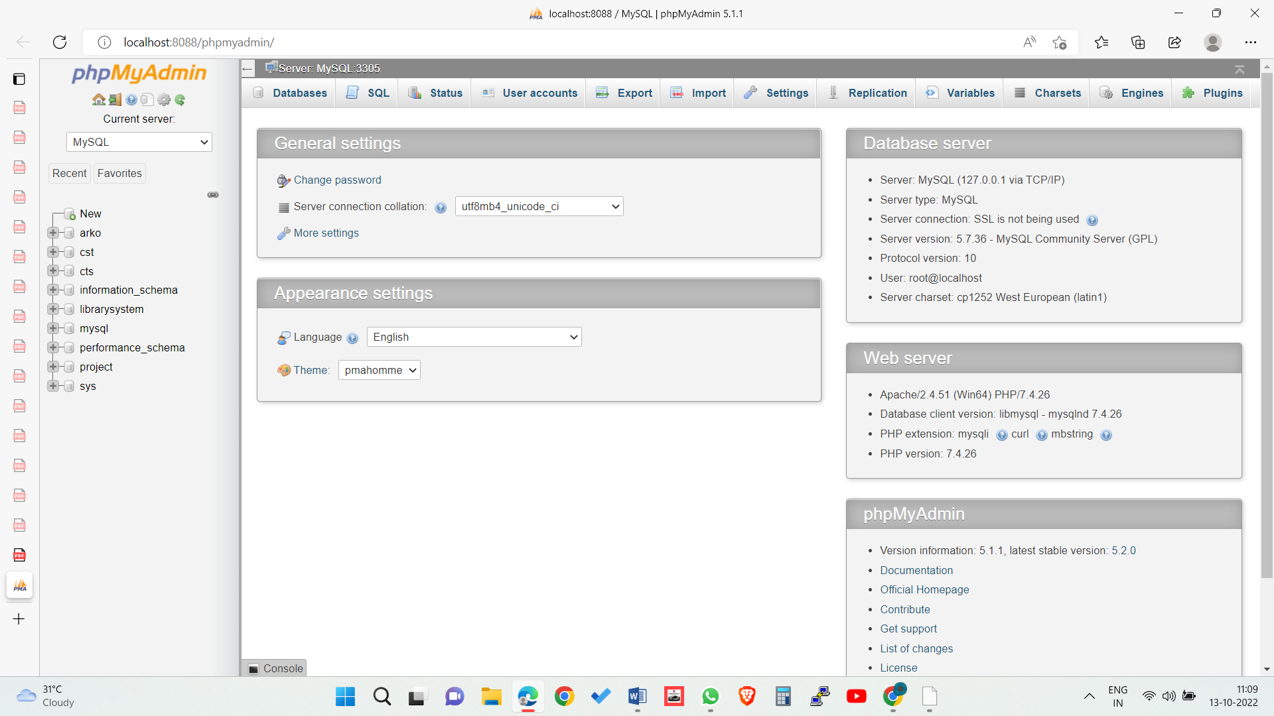

It is the most popular application for MySQL database management. We can create, update, drop, alter, delete, import, and export MySQL database tables by using this software. phpMyAdmin also supports a wide range of operation like managing databases, relations, tables, columns, indexes, permissions, and users, etc., on MySQL and MariaDB. These operations can be performed via user interface, while we still have the ability to execute any SQL statement.

phpMyAdmin is translated into 72 languages and also supports both RTL and LTR languages so that the wide range of people can easily use this software. We can run MySQL queries, repair, optimized, check tables, and also execute other database management commands. phpMyAdmin can also be used to perform administrative tasks such as database creation, query execution.

phpMyAdmin is a GUI-based application which is used to manage MySQL database. We can manually create database and table and execute the query on them. It provides a web-based interface and can run on any server. Since it is web-based, so we can access it from any computer.

Features of phpMyAdmin :

* phpMyAdmin supports several features that are given below:
* phpMyAdmin can create, alter, browse, and drop databases, views, tables, columns, and indexes.
* It can display multiple results sets through queries and stored procedures.
* phpMyAdmin use stored procedure and queries to display multiple results sets.
* It supports foreign keys and InnoDB tables.
* phpMyAdmin can track the changes done on databases, views, and tables.
* We can also create PDF graphics of our database layout.
* phpMyAdmin can be exported into various formats such as XML, CSV, PDF, ISO/IEC 26300 - OpenDocument Text and Spreadsheet.
* It supports mysqli, which is the improved MySQL extension.
* phpMyAdmin can interact with 80 different languages.
* phpMyAdmin can edit, execute, and bookmark any SQL-statements and even batch-queries.
* By using a set of pre-defined functions, it can transform stored data into any format. For example - BLOB-data as image or download-link.
* It provides the facility to backup the database into different forms.

Advantage of phpMyAdmin :

* phpMyAdmin can run on any server or any OS as it has a web browser.
* We can easily create, delete, and edit the database and can manage all elements using the graphical interface of phpMyAdmin, which is much easier than MySQL command-line editor.
* phpMyAdmin helps us to control the user's permission and operate several servers at the same time.
* We can also backup our database and export the data into different formats like XML, CSV, SQL, PDF, OpenDocument Text, Excel, Word, and Spreadsheet, etc.
* We can execute complex SQL statements and queries, create and edit functions, triggers, and events using the graphical interface of phpMyAdmin.

Disadvantage of phpMyAdmin :

* phpMyAdmin is a simple interface, but quite tough for a beginner to learn.
* phpMyAdmin is difficult to install as it needs three more software tools before installation, which is- Apache server, PHP, and MySQL.
* We have to install all these software tools individually, whereas XAMPP already contains them in a single package. XAMPP is the easiest way to get phpMyAdmin.
* It has no schema visualization.
* phpMyAdmin is a web-based software tool which runs only on the browser, so It completely depends on browsers.
* It does not have auto-compilation capability.

Data Backup problem with phpMyAdmin

phpMyAdmin lacks a lot of features in import/export functionality. There are some backup problems with phpMyAdmin that are given below :

* Scheduling - There is no way to export the data of the database in phpMyAdmin automatically.
* Storage media support - As we have discussed earlier, phpMyAdmin is web-based software, so it runs only on the browser. We can take backups only to local drives of our system.
* Compression, Encryption, and other option - The files which are exported with phpMyAdmin are saved as common text files, with any additional processing. Whereas storing these files in the original form usually takes a lot of disk storage.

Prerequisite

* Web server - Apache, Nginx, IIS
* PHP
* Database - MySQL, MariaDB
* Web Browser
* Web server - phpMyAdmin's interface is based on our web browser, we need a web server to keep phpMyAdmin's files inside it. Apache and IIS are popular web servers. We can download Apache web server from here http://mirrors.estointernet.in/apache//httpd/.

PHP - We also need to install PHP 5.3 or upper version to support different functionalities. It contains different extensions to provide support for these functionalities. For example -

Session support -SPL (Standard PHP Library) extension

Uploading of ZIP files support -PHP zip extension

Cookie authentication - mcrypt extension

Open Document Spreadsheet and XML importing support -libxml extension

We can download PHP from here. https://www.php.net/downloads.php.

Database - phpMyAdmin supports databases, i.e.

MySQL 5.5 or latest versions

MariaDB 5.5 or latest versions

Web Browser - Web browser is required to access phpMyAdmin with enabled cookie and JavaScript. It can be Chrome, Internet Explorer, etc.

Connection of php to sql server:

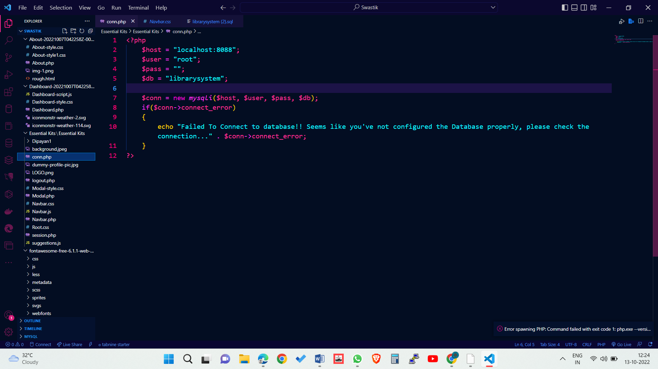

This particaular code will help you to connect the sql server and access the database through php.

**Use of CSS :**

Cascading Style Sheets (CSS) is a stylesheet language used to describe the presentation of a document written in HTML or XML (including XML dialects such as SVG, MathML or XHTML). CSS describes how elements should be rendered on screen, on paper, in speech, or on other media.

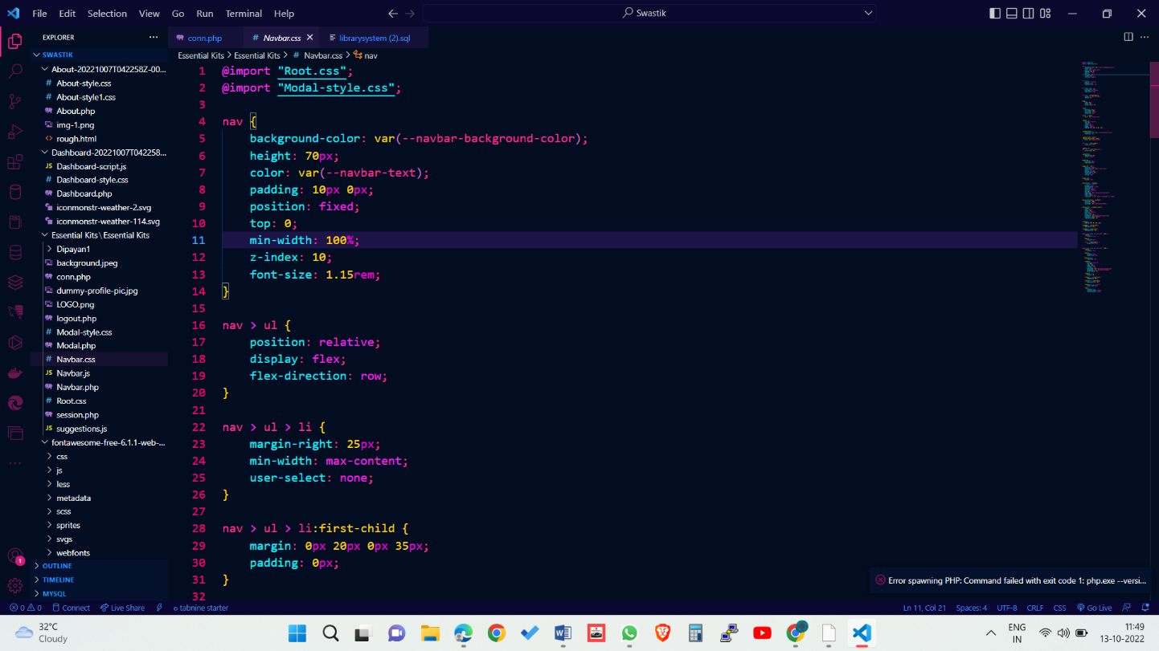

CSS is among the core languages of the open web and is standardized across Web browsers according to W3C specifications. Previously, the development of various parts of CSS specification was done synchronously, which allowed the versioning of the latest recommendations. You might have heard about CSS1, CSS2.1, or even CSS3. There will never be a CSS3 or a CSS4; rather, everything is now CSS without a version number.

A CSS Syntax rule consists of a selector, property, and its value. The selector points to the HTML element where CSS style is to be applied. The CSS property is separated by semicolons. It is a combination of selector name followed by the property: value pair that is defined for the specific selector.

Syntax:

selector { Property: value; }

There are several uses of CSS that are discussed as follows:

* Solves a big problem : Before CSS, tags like font, color, background style, element alignments, border, and size had to be repeated on every web page. This was a very long process. For example, If we are making a large website where fonts and color information are required to add on every page, it will be a long process. CSS was created to solve this problem. It was a W3C recommendation.
* Saves a lot of time : CSS style definitions are saved in external CSS files, so it is possible to change the entire website by changing just one file.
* Provide more attributes : CSS provides more detailed attributes than plain HTML to define the look and feel of the website.
* Pages load faster : CSS does not require the writing of HTML tag attributes every time. There is the writing of rule just once for a tag, which can be applied to all the occurrences of the corresponding tag. So using CSS, there is less code, which means faster downloading.
* Easier Website maintenance : CSS makes the maintenance of the website easier. It plays an essential role in website maintenance. If we require a global change in the file, it can be simply done by changing the style by which all the elements on the web page will update automatically. The CSS file provides a flexible look to the website, which can be altered in a convenient way. It also makes HTML formatting and modification of corresponding data elements easier.
* Multiple device compatibility : CSS is compatible with the older language versions so that we can use CSS with the earlier language versions. Because of this, if the CSS application is developed with the older programming language versions and if the developer combines the same with new improvements, then CSS can be easily implemented with the corresponding changes so the developer can update the existing code successfully. CSS allows the content to be optimized for more than one type of device.

After discussing the uses of CSS, it is clear that CSS is very helpful to style across different domains.

CSS file is added to any html file by using link tag which defines the relationship between the current document and an external resource.

Example :

<link rel="stylesheet" href="styles.css">

**Programming through VSCode :**

Visual Studio Code, also commonly referred to as VS Code, is a source-code editor made by Microsoft with the Electron Framework, for Windows, Linux and macOS. Features include support for debugging, syntax highlighting, intelligent code completion, snippets, code refactoring, and embedded Git. Users can change the theme, keyboard shortcuts, preferences, and install extensions that add additional functionality.

In the Stack Overflow 2021 Developer Survey, Visual Studio Code was ranked the most popular developer environment tool among 82,000 respondents, with 70% reporting that they use it.

Features of VS Code :

* Visual Studio Code is a source-code editor that can be used with a variety of programming languages, including Java, JavaScript, Go, Node.js, Python, C++, C, Rust and Fortran. It is based on the Electron framework, which is used to develop Node.js web applications that run on the Blink layout engine. Visual Studio Code employs the same editor component (codenamed "Monaco") used in Azure DevOps (formerly called Visual Studio Online and Visual Studio Team Services).
* Out of the box, Visual Studio Code includes basic support for most common programming languages. This basic support includes syntax highlighting, bracket matching, code folding, and configurable snippets. Visual Studio Code also ships with IntelliSense for JavaScript, TypeScript, JSON, CSS, and HTML, as well as debugging support for Node.js. Support for additional languages can be provided by freely available extensions on the VS Code Marketplace.
* An orange version of the Visual Studio Code logo for the insiders version of Visual Studio Code
* Visual Studio Code Insiders logo
* Instead of a project system, it allows users to open one or more directories, which can then be saved in workspaces for future reuse. This allows it to operate as a language-agnostic code editor for any language. It supports many programming languages and a set of features that differs per language. Unwanted files and folders can be excluded from the project tree via the settings. Many Visual Studio Code features are not exposed through menus or the user interface but can be accessed via the command palette.
* Visual Studio Code can be extended via extensions, available through a central repository. This includes additions to the editor and language support. A notable feature is the ability to create extensions that add support for new languages, themes, debuggers, time travel debuggers, perform static code analysis, and add code linters using the Language Server Protocol.

**Total Procedure of Searching, demanding and borrowing a book :**

Following are the procedures which student should follow for

Step 1 : Login to your account through about page .

Step 2 : After sucessfully loging in, click on the Search book option in the top navigation bar of the dashboard.

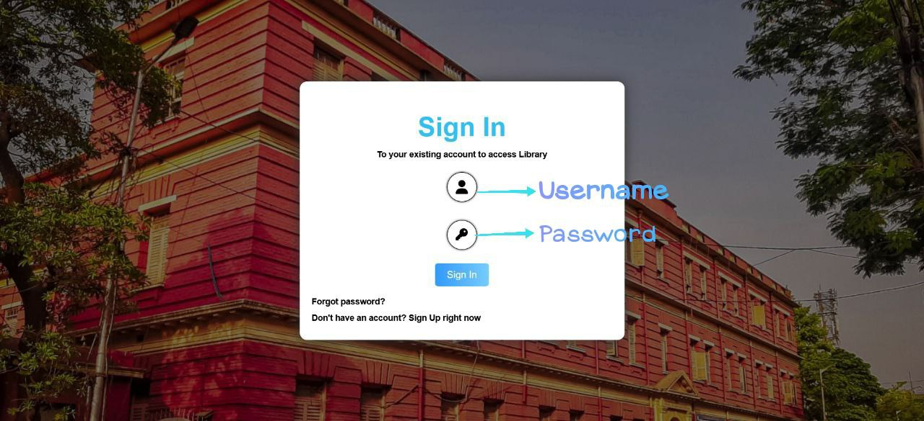

Step 3 : On the Search bar, Search the required book by its title, or by author’s name.



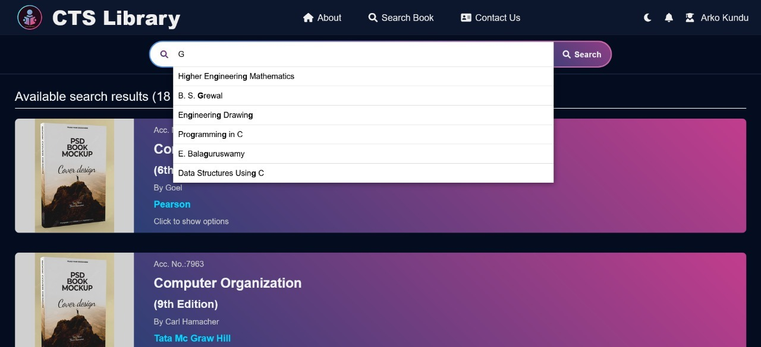

Step 4 : Click on the book which is required to demand and click on the option add to demand list. The book is no successfully demanded and you can see it in the demanded books option.



You cannot give book demand further before 3 days and if you have taken 3 books, you cannot demand no more books.

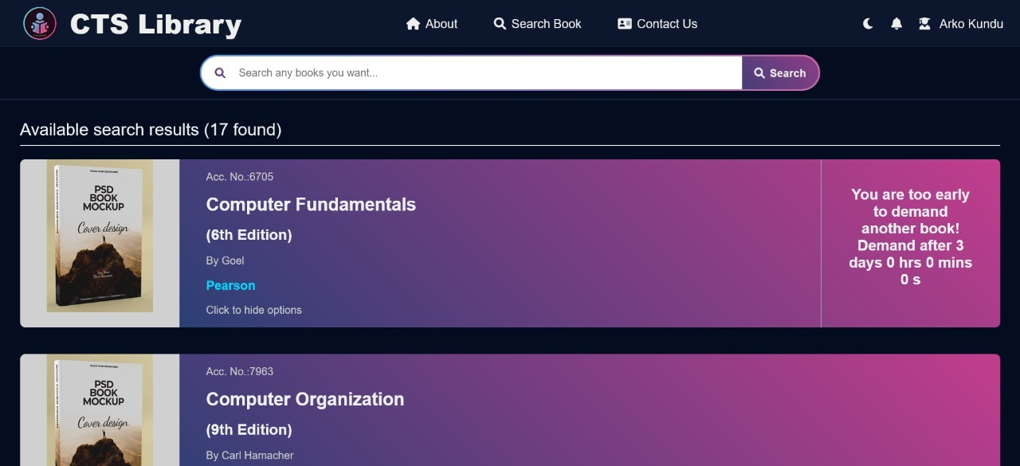

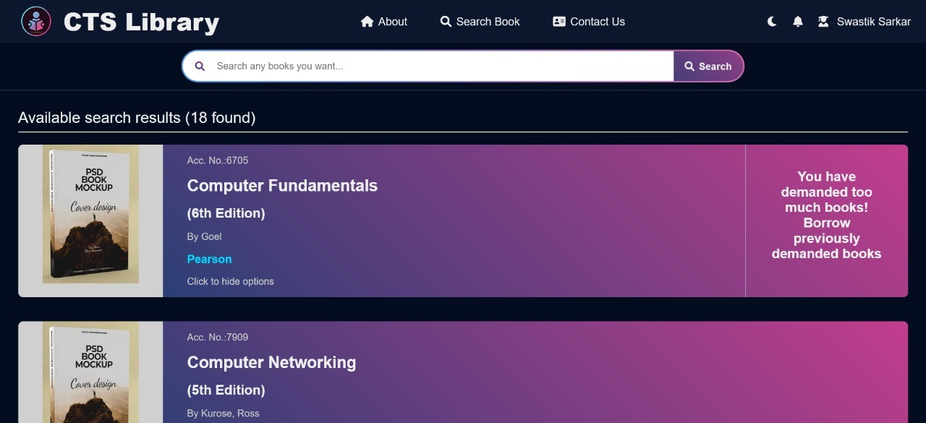

Step 5 : If you want to cancel the demand , from the option demanded books in the dashboard, click on Cancel Demand.

Step 6 : When you have successfully borrowed the book, you will click on the add to borrowed list option in the dashboard.

Step 7 : If you want to return the book to the library, Click on Return book option in the borrowed book section.

**Rules and Regulations inside Library premises :**

* Every students enrolled in the current academic session are eligible to have the following Library Services :
  + Lending facilities
  + Reading room facilities
  + Providing Syllabi & Previous Question Papers.
  + Reference Services
  + OPAC (Online Public Access Cataloguing) search facility of library holding (one computer is kept in the library for members for this purpose)
  + Reprographic Service
* Students will apply for issuance of Book Lending card only in groups of minimum 4 and Maximum 6 heads. Everyone in the Group will be held responsible for other group mates who shall not return books in due time or damage the same.
* For Getting Library Lending Card for the first time students have to submit the following documents to the Librarian:
  + Joint application in the scheduled format
  + Identity Card issued by the Principal, CTS
  + Money Receipt for admission in the institute
  + Latest P.P. size photo -1 copy
* Lending card shall have to be renewed in every academic session in Groups.
* Identity Card must be produced for Reference Reading in the library.
* Demand/Requisition should be placed before borrowing any book.
* The maximum number of books one can borrow from the library through Lending Card are :
  + 2 books – for 1st Year student
  + 3 books – for 2nd Year student
  + 4 books – for 3rd Year student
* If books are damaged or lost those must be replaced by the new ones.
* Library Hours :
* Reading Hours :

From 10.30 am to 4.50 pm – from Monday to Friday (except holidays)

From 10.30 am to 1.30 pm – Saturday (except holidays)

* Hours for Issue/Return of Lending books :

From 12 noon to 3 pm – from Monday to Friday

From 12 noon to 1.30 pm – Saturday

* Students willing to transfer from this institute to another must return their books to get Library Clearance.
* Final year students must have the Clearance Certificate from the library well before publication of their results for receiving their Mark sheets. Here Group clearance is must.
* Each year before filling in Forms to appear for final examination, students must return all their books
* Late Fine @ Rs. 2/- per book per week or part thereof will be charged for return of the books after due date.
* In case of mutilation /loss of lending card an amount of Rs. 25/- will be charged for issuing after due date.
* Librarian has the discretion to cancel or suspend the Library membership of a student if he/she found to break the rules.
* Students can suggest books on their subjects of study to be purchased for the library in the continuous manner around the year.

**DFD Model :**

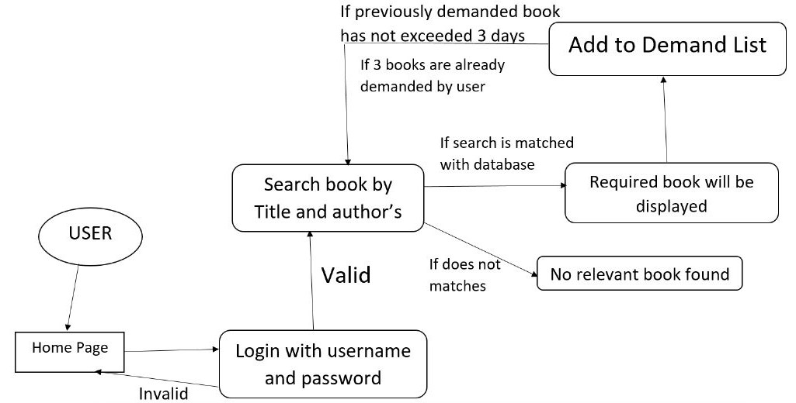

1. **Conclusion and Scope of Further Study**

This website provides a computerized version of library management system which will

benefit the students.

It makes entire process online where student can search books, demand book and borrow books. It also has a facility for student login where student can login and can see status of books issued as well request for book or give some suggestions through contact us.

The future scope of this library system are :

1. Forgot password feature
2. Profile change by user feature
3. Full Admin supported system
4. Settings modification as required.
5. **References**

1. Danny Goodman , Michael Morrison, Paul Novitski , Tia Gustaff Rayl, JavaScript Bible
2. Jon Duckett, HTML & CSS
3. Abraham Silberschatz, Henry F. Korth , S. Sudarshan, Database System Concepts
4. www.freecodecamp.org
5. [www.w3schools.com](http://www.w3schools.com)